|  |
| --- |
| Circle Language Spec: Inheritance |

## Object Inheritance

An object can merge with another object, delegating its interface, implementation *and* its values to another object:

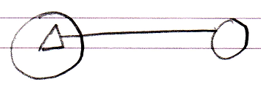

So this time the interface has an object line. This means that as soon as the other object’s values change, the derived object is automatically also changed. The other way around is also true: when you change the derived object’s inherited members, the base object also changes. Changes are not *applied* from one to the other: both are just references to exactly the same object.